**Forum:** Special Conference on Southeast and Central Asia

**Issue:** Questions on Israel-Palestine Border

**Student Officer:** Yichu Huang

**Position:** Chair of Special Conference on Southeast and Central Asia

Introduction

The Israeli Palestine conflict arose many centuries ago and has quite a complicated nature. It is mainly concerned with the idea of Zionism, which is a movement for re-establishing a Jewish nation. Specifically speaking, the Jews wanted a self-governed state within Palestine. The idea of Zionism rose many centuries ago, reaching its peak in the 20th during post Second World War era. This eventually forced the United Nation to intervene the issue, who recommended giving more than half of Palestine land to establishing a Jewish land despite the fact that the Jews only counts for an extremely low portion of the entire Palestinian population.

Although countries such as the United States and USSR recognized Israel within the first 24 hours of its establishment, the Arabic states did not. In 1948, Israel broke into conflict with neighboring Arab states. Through the war of 1948, Israel gained up to 77% of Palestine territory, expanding its border to the West Bank. This was marked by the boarding line, known as ‘The Green Line’.

In the years that followed, there had been several uprisings against Israel occupation in the West Bank area, known as ‘Intifada’. First negotiation between party leaders in both Israel and Palestine took place in Oslo, 1993.

Current tension between Israel and Palestine is on the separation wall that Israel insists on building. This wall includes a portion into the highly disputed West Bank region. Although for Israel, it will act as a security defense but to Palestine, it is a “Apartheid Wall”. Civilians’ life has been severely affected, cases of injuring, kidnapping and killing have been reported. The question of Israel and Palestine border has caused severe tension both regionally and internationally.

Definition of Key Terms

**Zionism**

Zionism can be interpreted originally as the re-establishment of a Jewish State; now it is the protection of the Jewish nation Israel. It began in the late 1800s. However, there are large disputes over this topic and was considered by the UN a form a racial segregation.

**Jew**

Judaism is the traditional religion of the Jewish people. They trace their origins through the ancient Hebrew people of Israel to Abraham.

**Arab**

People who are originally from the Arabian Peninsula and neighboring territories, inhabiting much of the Middle East and North Africa. Countries that contain large Arab inhabitants such as Egypt, Jordan and Palestine make up what is known as the Arab World.

**The Green Line**

The separation line between Israel and Palestine that was drawn in 1967. However, it is referred to as the demarcation line, rather than the permanent border between these countries.

**West Bank**

The main conflict area in the Israel Palestine problem. It is located west of the Jordan River and northwest of the Dead Sea. In 1948, it became part of Jordan however was later occupied by Israel after the 1967 Six Day War. 97% of the inhabitants in this region are Palestinians. In 1993 an agreement was signed to grant the Palestinians autonomy and Israeli troops began to withdrawal. Despite this, conflicts continue in this region.

**Intifada**

Due to the Israeli occupation of regions such as Gaza Strip and West Bank, Palestinians began a serious of uprising against the Israeli rule beginning in 1987.

**Hamas**

A movement which has the aim of establishing a Palestinian state incorporating Israel and the West Ban region.

**Palestine**

In 1920, the name Palestine was used as the official title for the British mandated land that was west of Jordan. However, in 1948, after the establishment of the state of Israel, many traditional Palestinian lands were occupied by Israel. Ever since then the Palestinians have been fighting for autonomy and conflicts still continue in this region.

**Israel**

In 1948, the modern state of Israel was established. However, it was immediately opposed by surrounding Arab states that later attack Israel but was defeated. Due to the fact that Israel was established in what was back then the Palestinian land, conflicts continue between Israel and the neighboring Arab states, mainly over the issue of rights of Palestinians whose displaced from their homes and treated unequally in Israel. As a result, continual tension and intermittent terrorist and military activities have surrounded this region ever since. Many approaches have been taken, yet conflict still grows over this region.

General Overview

Zionism and establishment of Israel

It all began with the mass immigration of Jews population to Palestinian land in the 19th century. During the Second World War, Hitler rose to power and more Jews refugees moved to Palestine. At the beginning, there was no conflict. The Jews and Arabs traded and lived peacefully together. However, a small group of Jews, known as the Zionist, wanted to establish a Jews homeland. In the post-war era, the idea of Zionism was supported by Western countries such as the U.K. and U.S., which eventually lead to the establishment of the state of Israel. However, instead of the adhering the principle of “self-determination of peoples” (the people within a country divide the land up), this was done through the United Nations, who recommended giving 55% of Palestine land to establishing the Jews state despite the whole population only accounts for 30% demographical wise.

1947-1949 War

Known as the war of independence to Israel and Nakba, or catastrophe, by the Arabs, the war allowed Israel to expand its territory. Five Arab States including Syria and Iraq fought against Israel during the war. It is important to understand two factors about this war as they serve as the very objective basis for today’s conflict. Firstly, the Arabs only declared war on Israel after it committed 16 massacres, with the massacre of Deir Yassin where more than 100 men, women and children were brutally killed. In total, Israel committed 33 massacres. Secondly, no fighting was done within Israel; all of the fighting took place within Palestine land. Through the war, Israel conquered 78% of Palestine and pushed its boundary to include parts of West Bank. Separated by the “Green Line” between Palestine, the state of Israel was well established while fulfilling the conquest of Zionism. By the end of the war, more than three quarters of Palestine citizens had been made refugees. A new map was created with almost all aspect of Palestinian culture removed: A Hebrew name was given to every city and river. The former Prime Minister of Israel stated that “There were no such thing as Palestinians.”

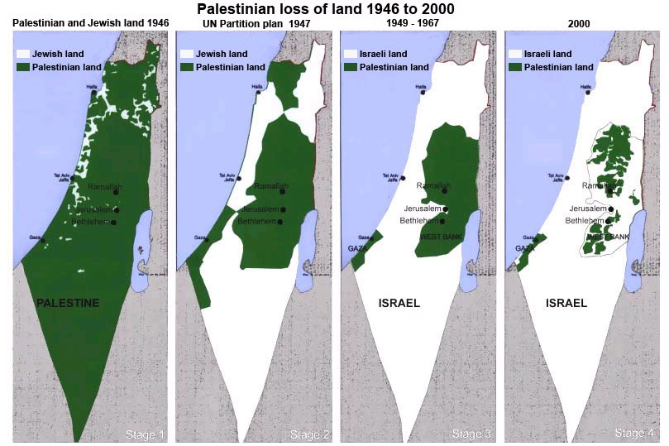

*Territorial change between Israel and Palestine*

*Western relations and military improvement (1949-1957)*

During this period of time, Israel was deeply concerned with security as it is surrounded by hostile Arab states that refused to recognize Israel’s independence. Additionally, armistice lines were drawn arbitrarily which caused more conflict between the Jews and Arabs. With western support, Israel was able to boost its military strength. During the cold war, the United States looked for support from Israel government in particular. Although relations between the two countries were close, certain issues remained unsolved. However, it is during this time that Israel grew its military strength and became a leading military power in the Middle East region.

Six Day War and gaining of West Bank

Israel fought a war in 1967 with the surrounding Arab states. This war further helped Israel to expand its territory as regions such as the Sinai Peninsula, the West Bank and the Gaza Strip.

U.S. Involvement

Ever since the creation of Israel, U.S. taxpayers have been funding this nation more than any other country, which is about 10 million dollars per day. However, many are calling an end of this expenditure due to this enormous amount paid. Despite the callings, one third of U.S.’s foreign budget still goes to Israel. More recently, President Donald Trump announced in one of his addresses that the United States recognizes Jerusalem as the capital of Israel. Once again, the involvement from the United States triggered another round of tension between the Arab states and Israel.

Separation Wall

The separation wall, also known as the West Bank Barrier, is deemed to be a defense wall by Israel while an “Apartheid Wall” by Palestine. By the end of 2012, 62% of the wall was completed with 8% still in construction and the final 30% unconstructed. However, in the years that followed little progress has been made. The construction of the wall as approved by Israeli Prime Minister Ariel Sharon in 2002 with the original purpose of stopping Palestinian suicide-bombers. While Israel have indeed experienced a decline of death rate because of suicide bombers, many Palestinians’ life has been severely affected by this wall.

Most of the barrier comprises a set of 2-meter-high, electrified barbed-wire fences with vehicle-barrier trenches and a 60-meter-wide exclusion zone on the Palestinian side. But in more densely populated urban areas, particularly those around Jerusalem, space limitations prompted the Israelis to instead build a concrete wall to the height of 8 meters. The approximately 15,000 residents of the village are surrounded on three sides by the barrier, which keeps its residents from regular access to the businesses, hospitals, cultural centers and other services in the Holy City. The wall affects both the Palestinians as well as the Jews, with more negative impacts on the lives of the Palestinians, especially those who were “trapped” in Israel by the wall. They were denied access in Israel simply because they were Palestinians.

The barrier has violated basic human right as it interrupts free movement. It also disrupts free flow of people, goods and services of Palestine, severely affecting Palestine’s economy. Due to this, Palestine’s economy is currently facing a depression. The wall also encompasses some of the most fertile land of Palestine which caused an estimated loss of 28 million USD in agricultural production. Agricultural products are a primary source of income for many families of that region. Since the construction of the wall, families haven been prohibited to go across and cultivate their own farmland, which has caused many Palestinian families to go in poverty. Even some of the Israel leaders has expressed views stating that the wall functions more than a security fence and serves more than a political purpose. It is greatly violating human rights as it also acts as a barrier for racial segregation against the Palestinians. Frankly speaking, Israel is disguising under the name of “security” to achieve its annexation of territories in Palestine.

Another big dispute is over the water resources. Israel has closed 65% of water resources in West Bank region and have left many Palestinian struggling. The barrier encloses many of the natural aquifers, which are main sources of water to the Palestinians living in West Bank region.

The Refugee Crisis

As a result of the war of 1948, a large number of Arab refugees were created. The exact number of refugees vary from source to source, from 20,000 (Israeli sources) to 726,000 (UN sources) to over 800,000 (Arab sources) refugees. Regardless of the sources, it is important to pay attention to the Palestinian refugees whom many were either forced out of their homes, or fled. A major issue surrounding this crisis is the conditions in refugee camps such as poverty and overcrowding. This issue has always created international tensions and is always brought up during UN conferences. Ever since 1949, this problem has been at the heart of the negotiations between Israel and the neighboring countries.

UN’s resolution 194 suggested several ways that this problem can be combatted which included the returning of refugees to their home country and paying for their lost damages. Several Arab states including Syria and strongly opposed this resolution at the beginning. However, they eventually accepted many of the refugees. For instance, many Palestinian refugees hold a permanent citizenship in Jordan and are also able to enjoy the benefits.

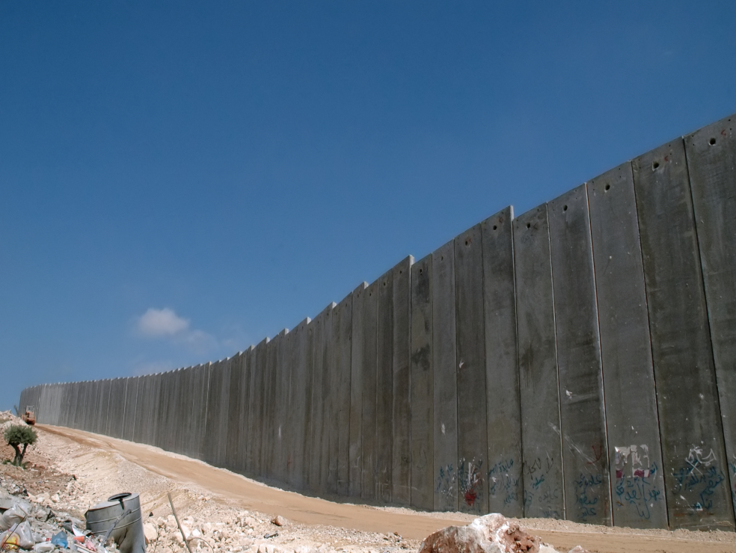

Separation Wall between Israel and Palestine

UN Involvement, Relevant Resolutions, Treaties and Events

**General Assembly Resolutions:**

***181***

This resolution was adopted in 1947 recommended giving 55% of Palestinian land away for the establishment of a Jewish State. This is often considered as the legal basis for the establishment of Israel. However, it was almost immediately opposed by member states of the Arab world.

***3379***

Resolution 3379 was passed in 1975 and classified Zionism as a form of racism and racial discrimination.

**Security Council Resolutions:**

***242***

Resolution 242 was issued after the 1967 war and called for the withdrawal of Israeli armed forces from the recently occupied territories and a "just settlement of the refugee problem". However, the specific reference to Palestinian refugees was not mentioned anywhere in the Resolution 242. It also speaks of the necessity for "sovereignty, territorial integrity and political independence of every state in the area and their right to live in peace within secure and recognized boundaries."

International Court of Justice

*Advisory opinion on Israel West Bank Barrier*

The international Court of Justice declared the West Bank Barrier, also known as separation wall or defense wall, to have violated international law and ordered its immediate removed. Additionally, the court’s ruling urged Israel to compensate Palestine’s losses. However, joined by the United States, Russia, and the EU, Israel ultimately did not participate in the trial.

Timeline of Events

|  |
| --- |
|  |
| |  |  | | --- | --- | | **Date** | **Description of Event** | | 1882-1939 | Major wave of Jews immigration to Palestine. | | 1917 | British Government made supportive commitment in Jews nationalism under the Balfour Declaration. | | 1922 | Ottoman empire lost territorial rights in Palestine at the end of the First World War. The League of Nations approved British military control in Palestine. | | 1947 | United Nations passed resolution which released Great Britain from duties toward the Jews and Arabs in Palestine. | | 1948 | The Israel War of 1948. Known as War of Independence or Nakba. | | 14th, May 1948 | Israel declared independence as a nation. Within hours, the United States and USSR recognized the nation. | | 1978 | Israel and Egypt Peace Treaty signed at the White House. | | 1987 | First Palestinian uprising against Israeli rule which brought international attention. | | 1993 | Oslo Accords: First face-to-face negotiation between Israeli and Palestinian party’s leaders. Agreement was made on the removal of Israel’s defense wall from the West Bank and Gaza Strip region. Relations between Israel and Palestine began to improve. | | 2004 | Advisory opinion from International Court of Justice ordered the immediate removal of the separation wall and considered it as illegal. However, it did not stop Israel from further constructions of the wall as Israel ultimately denied the trial. | | 2006 | Hamas, who won the election in Palestine in 2006, refused to accept any previous agreement made by the Palestinian Government as well as refused to recognize Israel as a state. Relationship between the two nations retrograded and conflicts worsen. | |
|  |
|  |

Possible Solutions

As one of the main problem surrounding this issue is the problem with Palestinian refugees, it is necessary to take measures to protect the rights of these civilians involved. Safety, access to clean drinking water, education for children etc. must all be ensured. This can be done through means such as international cooperation and negotiation. Additionally, the UN should take approaches to ensure the basic human rights of these refugees. For instance, many Palestinians are denied free travel whereas the Jews can travel around the world. Thus, it is important for UN to take firm measures to encourage nations, especially Israel to take the refugee issue with sympathy and treat them with the basic human needs and rights.

Measures need to be taken in order to have just trials of Palestinians that are imprisoned in Israel. Currently, many Palestinians that are imprisoned in Israel are denied a fair trial and many were thrown in prison simply because of their ethnicity. Cases that can be reassessed on international courts is to be encouraged as it can avoid bias and inequality.

The separation wall at the West Bank can be said to be the root of all these conflicts. Thus, formal international investigations into the issues of West Bank Barrier should be encouraged. For instance, officials from the UN should be sent for such investigations. Possible factors of investigation can include water resource and impact on agriculture. Plausible means of removing the barrier can also be effective. This can be achieved through ways such as international negotiation, and regional conferences between Israel, Palestine and bordering countries.

One of the moving global force and potential is among the young and educated. Fair and unbiased education to students around the globe will inform the them about the issue. Apathy towards the issue should be eliminated and people should be made aware of the issues that are happening around the world. The UN should take strong approaches to encourage countries, not only those ones that are directly involved in the conflict, but also other nations around the world to educate their population about this issue. This can be done through means such as mass media communication, implementing courses in school that help students to understand the importance of these global issues, even if it’s not affecting them directly.

Promote ways such as economic sanctions and international pressure against Israel as it denies removing the West Bank Barrier can also be effective. However, this means that other measures need to be taken in order to stop terrorism to ensure the safety of Israel once the wall is removed. For instance, urging Israel to enhance its border security and checks, and allowing universal access to records and names of international terrorists’ groups or individuals. Other means includes implementing technology-based methods. For example, unmanned drones to have regular checks around the border to ensure the safety of Israel.

Bibliography

“Fact Sheets.” *The International Court of Justice & Israel’s Security Fence*, [www.jewishvirtuallibrary.org/the-international-court-of-justice-and-israel-rsquo-s-security-fence](http://www.jewishvirtuallibrary.org/the-international-court-of-justice-and-israel-rsquo-s-security-fence).

Bartal, Shaul. “The Palestinian Refugee Problem Resolved.” *Middle East Forum*, Middle East Forum, [www.meforum.org/3643/palestinian-refugee-problem](http://www.meforum.org/3643/palestinian-refugee-problem).

If Americans knew. “A Synopsis of the Israel/Palestine Conflict.” *Ifamericaknew.org*, If Americans Knew, [www.ifamericaknew.org/history/#_edn8](http://www.ifamericaknew.org/history/#_edn8).

Jeffery, Simon. “Key UN Resolutions on the Israeli-Palestinian Conflict.” *The Guardian*, The Guardian, 2003, [www.theguardian.com/world/2003/oct/22/israel2](http://www.theguardian.com/world/2003/oct/22/israel2).

“Nations Borders Identities Conflict.” *Nations Borders Identities Conflict - Israel-Palestine Conflict*, [www.nbiconflict.web.unc.edu/conflicts/israel-palestine-conflict/](http://www.nbiconflict.web.unc.edu/conflicts/israel-palestine-conflict/).

“The Palestinian Refugees.” *Mideastweb: Middle East*, [www.mideastweb.org/refugees1.htm](http://www.mideastweb.org/refugees1.htm).

“Walled off: 12 Years of Israel's Separation Barrier.” *Al Jazeera America*, <http://america.aljazeera.com/articles/2014/3/12/visual-activism-activestillsphotographsthebarrierwall.html>